One -Day Skill Development Workshop
on
TanjorePainting in Fabric

Date: 23.09.2022 Time: 10. 30a.m to 4.00 p.m
Venue: Mini Auditorium No. of. Beneficiaries: 51
NAAS College
Madurai.

The Women’s Studies Centre of Madurai Kamaraj Universityorganized a One -Day Skill Development Workshop on “Tanjore Painting in Fabric” in collaboration with Nagarathinam Angalammal Arts and Science College, Madurai and Kokuyo Camlin Limited, Madurai . The workshop began with the welcome address by Dr.P.Karthiga, Head of the Department, Department of Tamil, Nagarathinam Angalammal Arts College. In her welcome address, She Welcomed the Resource Person Mr. Arun from Camlin Private Limited then she welcomed all the Staffs of Women’s Studies Centre, All the Staffs of NAAS college and the Participants. She welcomed the participants, Mr.Arun, Resource Person from Camlin private Limited. She also welcomed Dr.R.Radhika Devi, Director i/c, Women’s Studies Centre, Madurai Kamaraj University, Madurai and other staff members from Women’s Studies Centre, Madurai Kamaraj University.
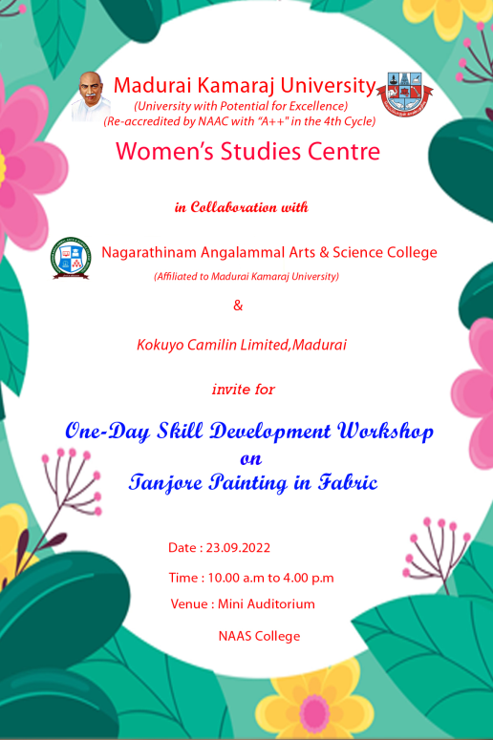

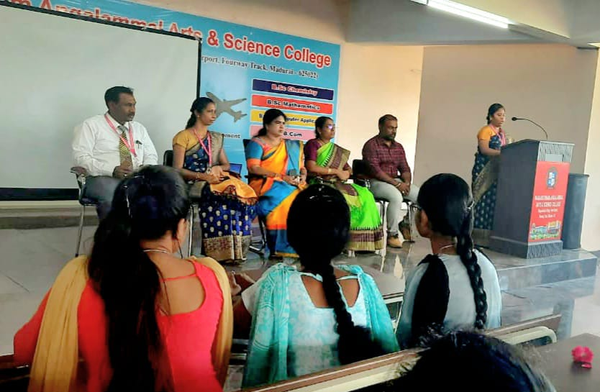

After the welcome address, special address was given by Dr.R.Radhika Devi, Director i/c, Women’s Studies Centre, Madurai Kamaraj University, Madurai. She in her Special Address highlighted the importance of Skill Development Workshop by saying that skill development is required to enhance a particular individual’s competency. She commented in her speech that, the more we are developed in a particular skill the more we have chances of getting a job or business. Developing a particular skill makes us economically empowered.
Dr.R.Radhika Devi continued her speech by saying that painting is a skill that improves creativity within us.Painting could also give us relaxation and peace of mind. Studies prove that painting helps to improve our memory. Painting will improve our Emotional Intelligence. Painting drawn by us could be said as a self -esteem booster. Tanjorepainting is a classical art from Southern India. It is the celebration of the region’s rich artistic tradition, named after the town of Thanjavur in Tamil Nadu, India. Tanjore paintings are known for their extravagant depictions of deities using vibrant colours and bring an ornament touch to the paintings. Though the art form has undergone various changes over the years, it continues to be popular with lovers of art even today and inspires many artists with its true Indian style.She concluded her speech by requesting the participants to make use of the workshop.
After the special address the workshop began by providing the following materials for Tanjore painting to the participants.
- Cloth
- Cloth holding ring
- Colours (yellow,brown, green, maroon, black and white)
- Painting brushes-2
- 3Dliner
- Brown carbon paper/tracing paper
- Paper with designs
- Red and green stones
The Resource Person told the participants that India, being a country with diverse culture and the kind of art produced here is diverse ranging from Miniature paintings of the Mughal era to the classical style of the Tanjore paintings. A Tanjore painting gives attention to minute details in the drawing or in simple terms it highlights the minute details in the drawing. The Tanjore painting in fabric makes the fabric more beautiful and we can draw any kind of Tanjore paintings in the fabric. Many people would think painting in fabric may not be accurate, but it is not true, we can make wonderful paintings in fabric.
Many people think that conventional frame or traditional frame would be ideal for any kind of Art work, but successful art works are something extraordinary or an art that come out with creative solutions. Mr.Arun instructed the participants to trace the design using the brown carbon paper. A picture of a swan was given as a design to trace. The brown carbon paper is specifically used to trace the designs in the fabric. Cotton cloth was provided to the participants for painting. The participants were asked to place the tracing paper after the cloth. The tracing should be done by using a pen or pencil. The tracing paper should not be moved after the tracing has been started. The first step is to trace the outline of the design. The participants were asked to keep the tracing paper safely so that it might be helpful for them in the future. Tracing the design should be done carefully and if we leave the tracing in-
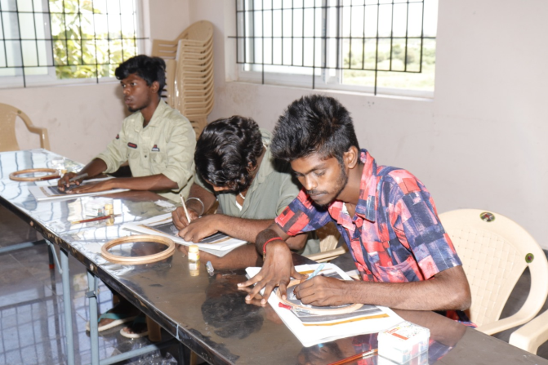
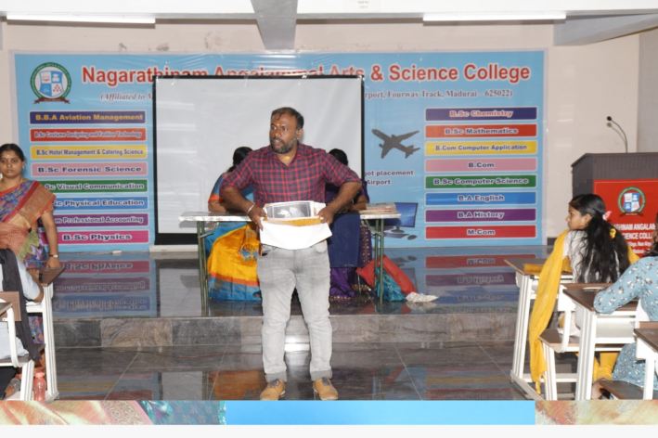

between we may not be able to find where we left. Mr.Arun ensured that all the participants have finished tracing the design. He instructed the participants to insert the fabric in the cloth holding ring which would stretch the cloth and make easier for doing painting in the fabric. Mr.Arun told the participants that painting should begin from top of the ring. The next step was to colour the outline of the picture with 3D outliner.
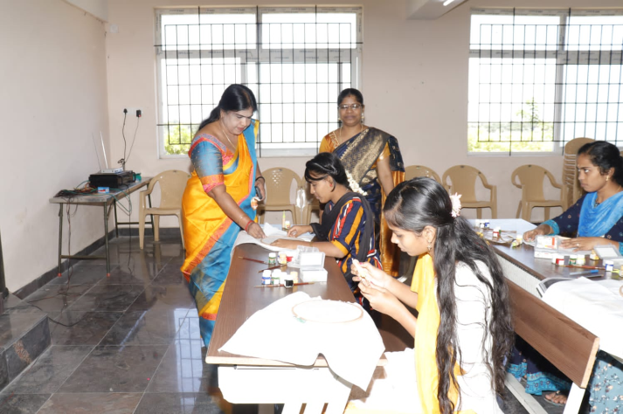
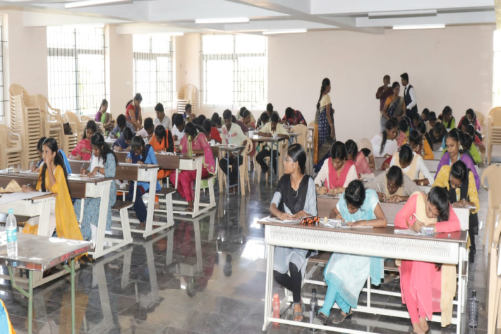

The 3D outliner was golden in colour. The participants were instructed not to mix too much of water with the colours as thick painting would bring better look for the fabric. Mr.Arun told the participants that as the colours are fabric colours (meant for fabric painting) it would not go away after washing the cloth. After giving colour to the outline, the participants were asked to give yellow colour to the head of the swan and in-between the neck of the swan also. The participants were asked to be careful while using the colours near the outer line. The participants after finishing with one colour were requested to allow the paintings to dry for five to ten minutes and then go for another colour.
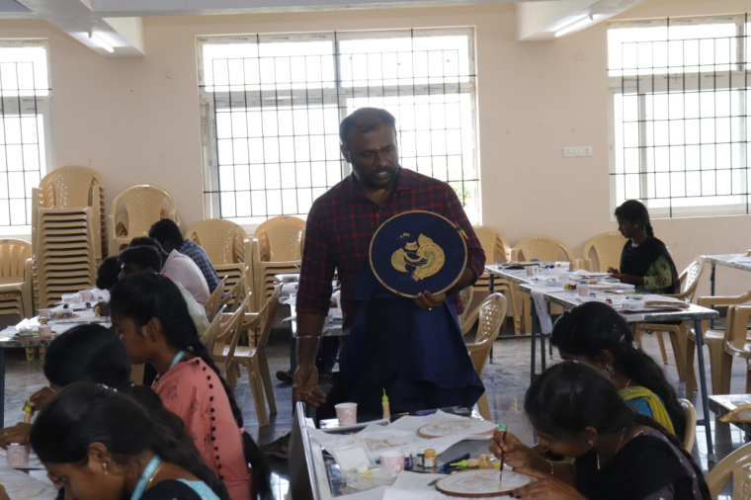

The participants were asked to give white colour in the wings of the swan, and light pink colour(red and white mix together gives pink colour) in the border of the wings and stripes in between the wings. The participants were requested to show their painting after they finish each step and clarify doubts in each step if they have. Mr.Arun told the participants that if we make a mistake in one single step that has a chance to spoil the entire painting.
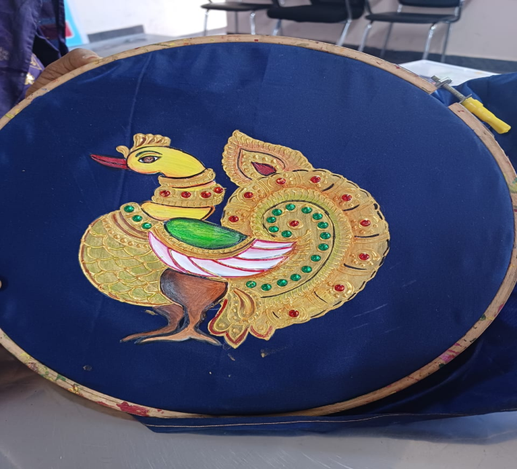

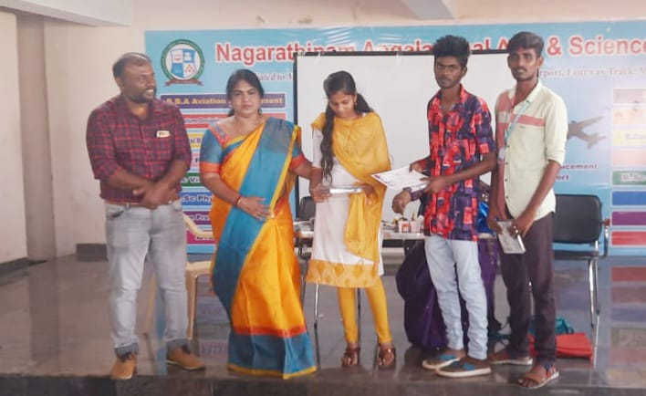
In the next step participants were asked to give brown colour to the legs of the swan. Next the participants were asked to give red colour to the beak of the swan. The participants were instructed to give green colour to the design above the wings. Then the participants were asked to paste the green stones in the first layer and red stones in the second layer (the design that connects from wings and legs of the swan) using 3D layer. The participant were instructed to paste red stones in the neck part of the swan and green stones after the neck part. The workshop came to an end with feedback session. In the feedback session, the Participants told that the workshop was very useful and interesting.

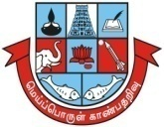
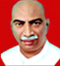
Madurai Kamaraj University
(University with Potential for Excellence)
(Re-accredited by NAAC with “ A⁺⁺’’ in the 4th Cycle)

WOMEN’S STUDIES CENTRE

In collaboration with

Nagarathinam Angalammal Arts & Science College, Madurai-22
(Affiliated to Madurai Kamaraj University)

Women’s Empowerment Cell

Organize
Women’s Day Celebration-2023

Date: 08th March 2023 No. of Benificiaries : 480
Venue: Malligai Arangam, Time: @ 01.30p.m.
NAAS College, Madurai.

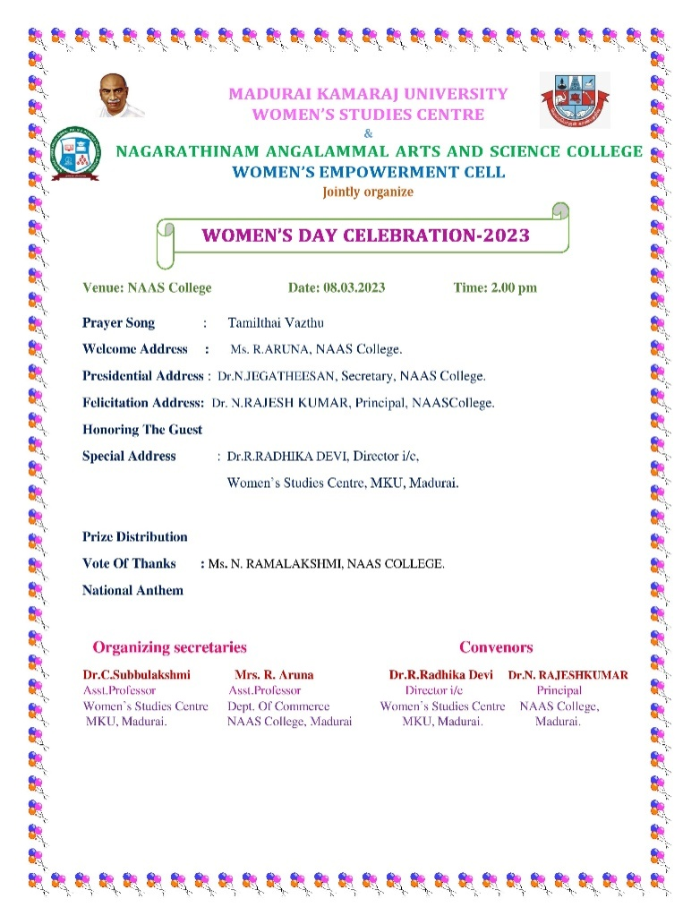
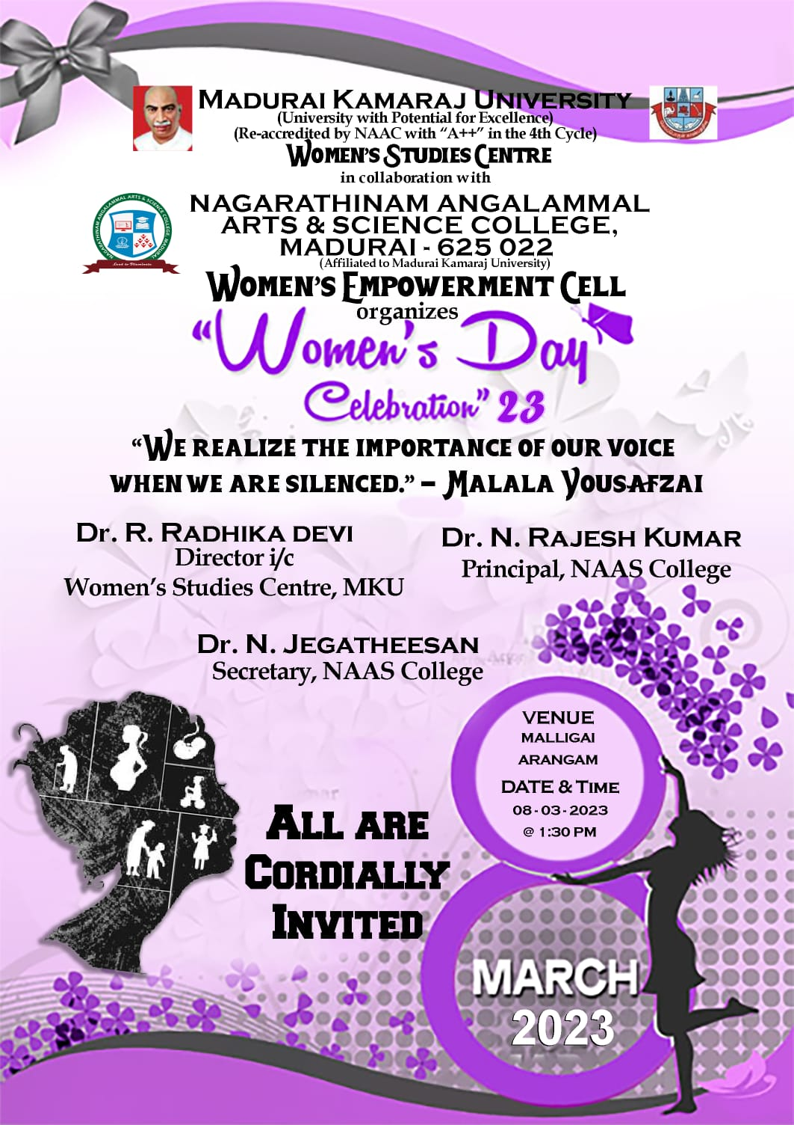

The Women’s Studies Centre of Madurai Kamaraj University, Madurai and Nagarathinam Angalammal Arts & Science College, Madurai jointly organized “Women’s Day Celebration-2023” on 08.03.2023 at Malligai Arangam, Nagarathinam Angalammal Arts & Science College, Madurai.
The program began with Tamil Thai Vazhthu, next the Welcome address was delivered by Mrs. R.Aruna, Assistant Professor, Dept. of Mathematics &Convenor, Women’s Empowerment Cell, Nagarathinam Angalammal Arts & Science College. She welcomed Dr. R. Radhika Devi, Director i/c, Women’s Studies Centre, Madurai Kamaraj University, faculty Members, non- Teaching Staff, and all the students. She told about the significance of celebrating International Women’s day on 8th march every year.
She further said that this day is celebratingto bring attention towards the issues based on gender equality, reproductive rights, and violence and abuse against women. International Women's Day is a collective day of global celebration and a call for gender parity. It is all about unity, celebration, reflection, advocacy and action. She honoured the special guestDr. R. Radhika Devi, Director i/c, Women’s Studies Centre, Madurai Kamaraj University, Madurai.
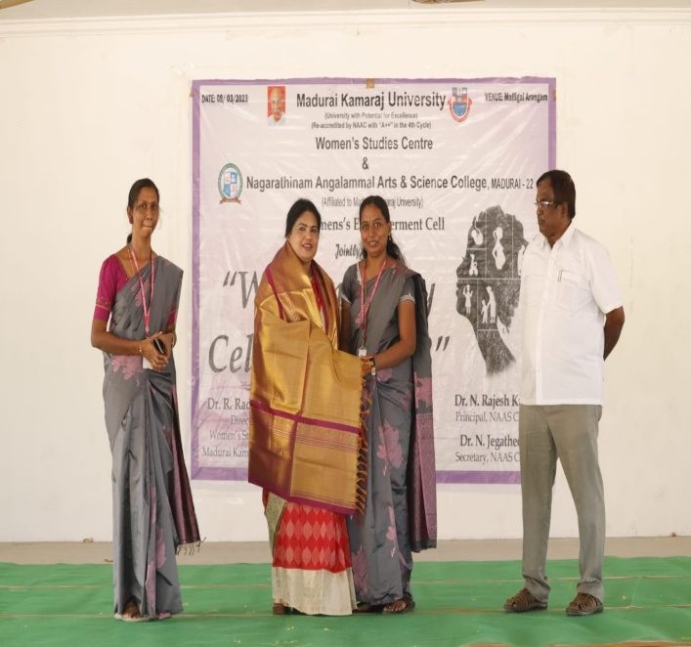

Presidential address was delivered by Dr. N. Jegatheesan, Secretary and Correspondent, Nagarathinam Angalammal Arts & Science College, Madurai. He began his speech by saying that the achievement of ancient woman leaders. He highlighted the Rani Lakshmi Bai, the Queen of Jhansi, led the Indian Rebellion of 1857 against the British. She is now widely considered as a national hero.
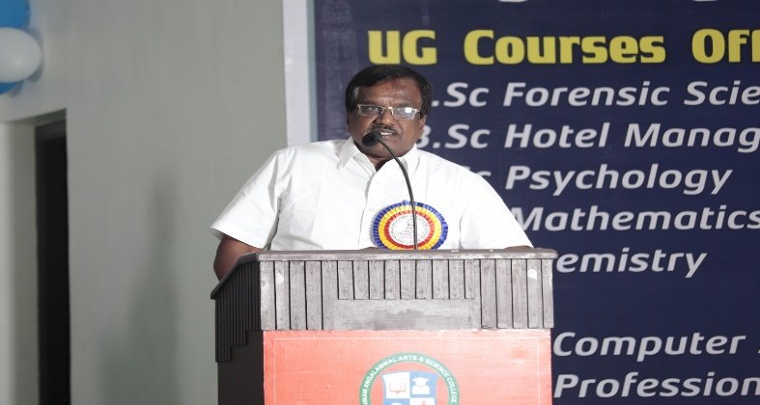

The felicitation address was delivered by Dr. N. Rajeshkumar, Principal,Nagarathinam Angalammal Arts and Science College, Madurai. He began by saying the role of women in the society and their achievements. He continued by highlighting the achievement of IndraNooyi as the chairperson and CEO of PepsiCo's until her retirement in 2019. She worked with the company for 24 years and spent over a decade in the top post.
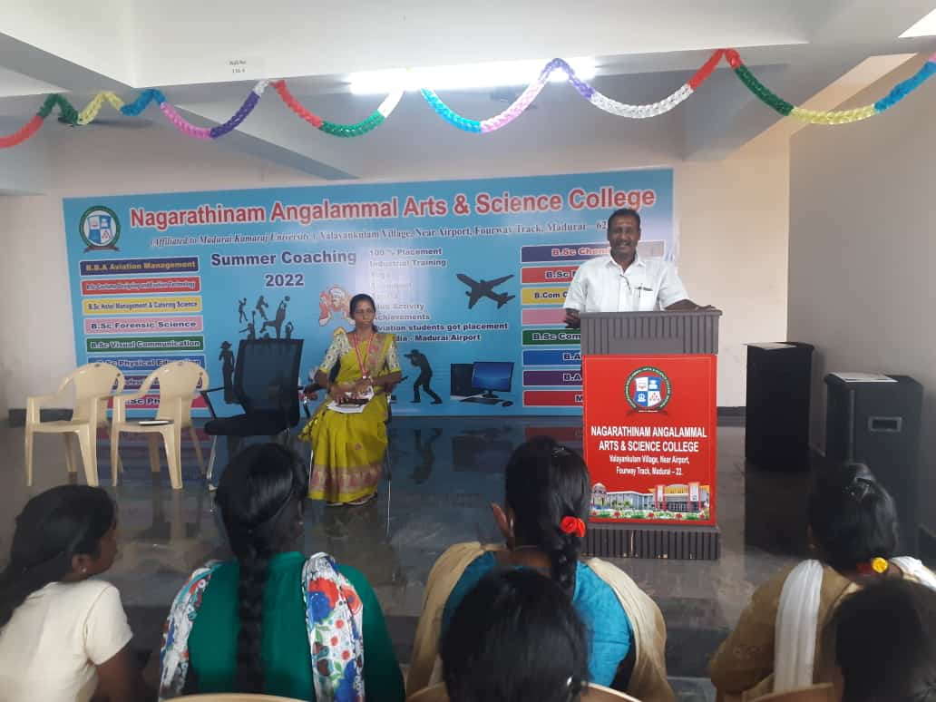

The special address was delivered by Dr. R. Radhika Devi, Director i/c, Women’s Studies Centre, Madurai Kamaraj University, Madurai. She began her speech by saying that the women of today being self-dependent and tough holding good position in the current society. She continued her speech by saying the awareness of women empowerment and also highlighted the women achievers like Hima Das as the first Indian athlete (sprint runner) to win gold at the IAAF World Under-20 Athletics Championship in 2018, held at Tampere, Finland. She currently holds the Indian national record in 400 meters, with a timing of 50.79s.Chungneijang Mary Kom Hmangte is an Indian Olympic boxer from Manipur. She is the only woman to achieve the coveted No. 1 position in the International Boxing Association (AIBA) after becoming the World Amateur Boxing champion for a six times record. Gita Gopinath is a Harvard economist who became the first Indian woman to assume the position of Chief Economist at IMF - the International Monetary Fund. She concluded her speech by motivating the students have the awareness towards the women empowerment.
On the occasion of Women’s day celebration 2023competitions were conducted for the girl students. The competitions are Elocution (Tamil & English), Poster Making,Mehandi, Cooking with fire, Pencil drawing and Group dance.
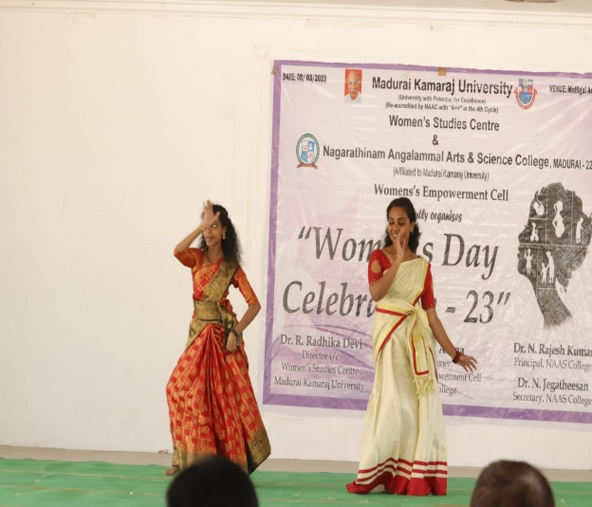
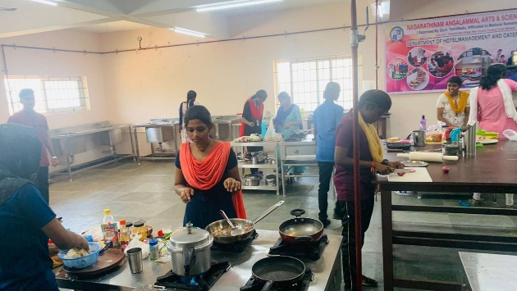

The prizes were distributed byDr. R. Radhika Devi, Director i/c, Women’s Studies Centre, Madurai Kamaraj University, Madurai to the students participated in the competitions.
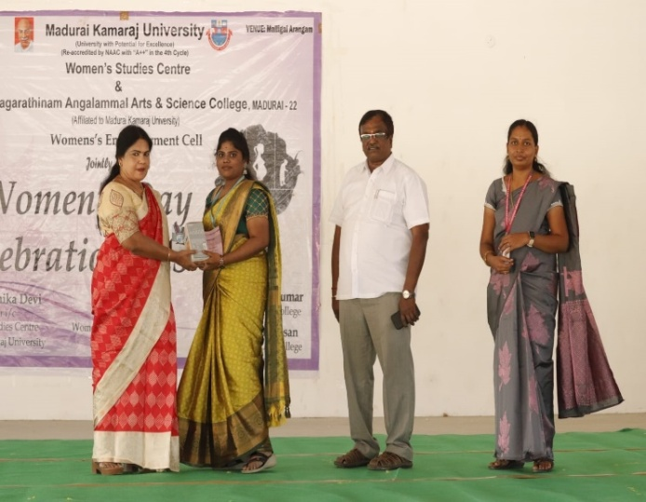
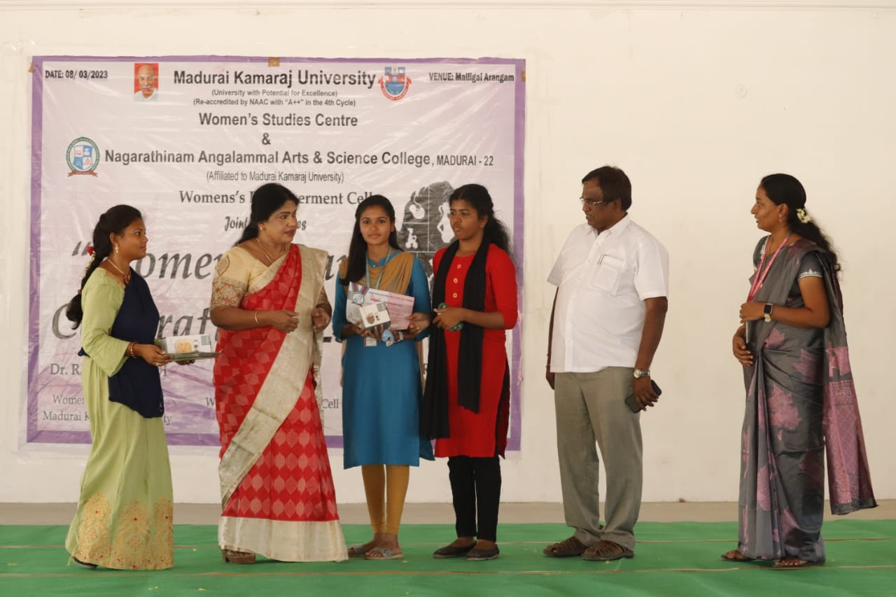

The program came to an end with Vote of thanks by Mrs N. Ramalakshmi Head& Assistant Professor Dept. of Constume Designing & Fashion Technology delivered the vote of thanks. She thanked Dr. R. Radhika Devi, Director i/c, Women’s Studies Centre, Madurai Kamaraj University, Madurai. Faculty Members, Non- Teaching Staff, and all the students of Nagarathinam Angalammal Arts & Science College, Madurai.

